
DATA VISUALIZATION PROJECT REPORT

SOCIAL MEDIA INSIGHTS AND TRENDS

Submitted by
K.JAHNAVI LALITHA SRIVANI

Registration No : 12215907
Program and Section : B.TECH (CSE), K22CA
Course Code: INT233

Under the Guidance of
Maneet Kaur : 15709

CERTIFICATE
This is to certify that K.Jahnavi Lalitha Srivani bearing Registration no. 12215907 has completed INT233 project titled, “Social Media Insights and Trends” under my guidance and supervision. To the best of my knowledge, the present work is the result of her original development, effort and study.

Maneet Kaur
Associate Professor
School of Computer Science & Engineering
Lovely Professional University Phagwara, Punjab.

Date : 15/11/2024

DECLARATION
I,K.Jahnavi Lalitha Srivani, student of B.TECH CSE under CSE/IT Discipline at Lovely Professional University, Punjab, hereby declare that all the information furnished in this project report is based on my own intensive work and is genuine.

Date: 15/11/2024 Registration No.: 12215907

Signature
K.Jahnavi

ACKNOWLEDGEMENT
I would like to express my heartfelt gratitude to my teacher, Mrs. Maneet Kaur, for providing me with the invaluable opportunity to work on this project, "Social Media Insights and Trends." This project has been a tremendous learning experience, allowing me to explore the dynamic world of social media metrics and data visualization. Through this project, I have gained hands-on experience with analytical tools, specifically Tableau, and learned how to interpret engagement trends and user interactions across platforms.
I am deeply appreciative of her guidance and support throughout the project, which has been instrumental in helping me understand the complexities of social media analytics and data representation.
I would also like to extend my sincere thanks to my parents and friends for their encouragement and support. Their constant motivation inspired me to complete this project successfully within the given timeframe. Their valuable feedback and insights greatly contributed to overcoming challenges and enhancing the quality of my work

Table Of Contents

- Introduction
- Scope of the analysis
- Existing System
- Source of the dataset
- ETL Process
- Analysis On dataset
- Introduction
- General Description
- Specific Requirements, functions and formulas
- Analysis results
- Visualization
(Dashboard)

- List of Analysis with results
- Future scope
- References

- Introduction
The project "Social Media Insights and Trends" aims to explore and analyze user engagement, content performance, and platform-specific trends across social media. In today's digital age, social media has become a powerful tool for individuals, businesses, and organizations to connect, communicate, and share information. With the exponential growth of social media platforms, vast amounts of data are generated daily, making it crucial to understand and interpret this data for strategic decision-making.
This project focuses on using data visualization techniques to interpret key engagement metrics, such as likes, retweets, and hashtag trends. Through Tableau, a powerful data visualization tool, we analyze factors including engagement by platform, engagement by country, popular hashtags, and user activity trends over time. The dashboard created offers a comprehensive view of social media engagement, providing insights into how users interact with content across different platforms.
The primary goal of this project is to identify patterns and trends in social media engagement, which can be valuable for businesses looking to optimize their online presence, improve customer engagement, and tailor content strategies to audience preferences. This project not only enhances data interpretation skills but also demonstrates the impact of social media analytics in today’s digital landscape.

2.Scope of the Analysis
The project “Social Media Insights and Trends” focuses on analyzing and visualizing key metrics related to user engagement across various social media platforms. The analysis aims to provide a comprehensive understanding of social media interactions, helping businesses, content creators, and organizations optimize their strategies for audience engagement.
Key areas of the analysis include:
1.Platform Engagement: Examination of user interactions such as likes, retweets, and shares across platforms like Twitter, Instagram, and Facebook to identify platform-specific trends and preferences.
2.Hashtag Analysis: Identification of the most popular hashtags to uncover trending topics and gauge their influence on user engagement.
3.Geographical Trends: Mapping engagement data by country or region to understand where the highest levels of interaction originate and analyze location-based patterns.
4.Temporal Trends: Monitoring user activity over time to uncover seasonal or periodic shifts in engagement metrics, such as spikes during events or holidays.
5.Comprehensive Visualization: Creation of an interactive Tableau dashboard to represent data insights visually, making complex datasets accessible and actionable for decision-makers.
This analysis is aimed at enabling informed, data-driven strategies that align with audience preferences and market dynamics, fostering better engagement and performance on social media platforms.

3. Existing System
The current methods for analyzing social media data primarily focus on isolated metrics, such as basic engagement statistics (likes, shares, retweets) or sentiment analysis. While these approaches provide valuable insights, they often lack the capability to offer a holistic view of user interactions across platforms, geographical locations, and time frames. Many existing tools either focus narrowly on specific aspects of engagement or require significant technical expertise, limiting their accessibility to non-technical users.
I)Drawbacks or Limitations of the existing system
a)Fragmented Data Analysis: Social media platforms provide their analytics tools, but these tools focus only on their respective platforms, making it challenging to compare trends across multiple platforms.
b)Limited Visual Representation: Existing systems often fail to present data in an intuitive and user-friendly manner, making it difficult for users to draw actionable insights from the analysis.
c)Geographical and Temporal Gaps: Many systems lack the ability to analyze data based on geography or time, which are critical for understanding localized trends or seasonal user behavior.
d)Hashtag Trends Underutilized: Popular hashtags are often analyzed in isolation without integrating their impact into broader engagement trends, leading to missed opportunities in content strategy.
e)Complexity for Non-Technical Users: Tools that provide comprehensive insights are often too complex or technical, requiring advanced data analytics knowledge to interpret results.
By addressing these limitations, “Social Media Insights and Trends “provides an integrated, visually rich solution that simplifies the process of analyzing and interpreting social media data.

4.Source of Dataset
The dataset used in this project was obtained from Kaggle, a popular platform for sharing datasets. Specifically, the dataset used for analyzing social media engagement and trends is titled "Sentimentdataset.csv" and can be found at https://www.kaggle.com/datasets/arpitagupta11/sentimentdataset-csv.
The dataset contains information about social media posts, including engagement metrics such as likes, shares, comments, and other relevant information. It was chosen for its comprehensive coverage of social media data, which aligns with the objectives of this project.

5.ETL Process
The ETL (Extract, Transform, Load) process was implemented to prepare the dataset for analysis and visualization in Tableau. Below is an outline of each stage in the process:
1.Extract
The dataset for this project was extracted from Kaggle, a well-known platform for publicly available datasets. The data was in CSV format and contained detailed information about social media posts, including engagement metrics such as likes, comments, shares, and post dates. The dataset was downloaded from the https://www.kaggle.com/datasets/arpitagupta11/sentimentdataset-csv and loaded into the working environment for further processing.
2.Transform
The data underwent several transformation steps to ensure its quality and suitability for analysis:
- Data Cleaning
- Missing values were handled either by imputing with appropriate defaults or by removing rows with excessive missing information.
- Duplicate entries were identified and removed to ensure the dataset’s accuracy.
- Columns were checked for consistency in terms of data types and standardized (e.g., ensuring date columns were in the correct format).

- Data Aggregation
- The data was aggregated by time periods (e.g., daily, weekly, or monthly) to analyze trends over time.
- Engagement metrics (likes, comments, shares) were combined to create an Engagement Rate field, which provides a more comprehensive measure of post performance.
- Data Filtering
- Only posts with significant engagement were retained, while posts with very low or no engagement were filtered out to maintain the quality of analysis.

3.Load
After the dataset was cleaned and transformed, it was loaded into Tableau for further analysis and visualization. The transformed data was imported into Tableau by connecting the cleaned CSV file. The dataset was verified to ensure that all fields were correctly loaded and that the calculated metrics, such as the Engagement Rate, displayed as expected.
The cleaned and processed data was then used to create various visualizations, which formed the basis of the Social Media Insights and Trends dashboard.

- Analysis on dataset.
I)Intoduction
In this section, we delve into the analysis of the social media dataset to uncover trends, patterns, and insights related to user engagement across different social media posts. The dataset includes engagement metrics such as likes, comments, shares, and post dates, which are crucial for understanding the effectiveness of social media content. The goal of this analysis is to identify key drivers of engagement and present the findings through visualizations.

II)General Description
The dataset consists of social media posts from various platforms (e.g., Twitter, Instagram, Facebook) and contains the following key attributes:
- Post ID: A unique identifier for each post.
- Post Date: The date when the post was made.
- Likes: The number of likes the post received.
- Comments: The number of comments on the post.
- Shares: The number of shares the post received.
- Engagement Rate: A calculated field representing the combined engagement (likes, comments, and shares) relative to the total reach or followers .
- Content Type: The type of content shared (e.g., image, video, text).
- Hashtags: Hashtags used in the post, which may correlate with engagement.
The dataset spans a range of posts over several months, providing a comprehensive view of social media performance during this period.
III)Specific Requirements,Functions and Formulaes
To derive meaningful insights from the data, several functions and formulas were applied:
- Data Cleaning: Removed missing values and duplicates to ensure the dataset’s integrity.
- Filtering and Grouping: Posts with low engagement were filtered out, and the data was grouped by content type, post date, and other relevant dimensions to facilitate comparison.
IV)Analysis Results
The analysis revealed several important insights:
- Engagement Trends: The analysis of monthly engagement rates showed that certain months had significantly higher engagement, often correlating with holidays, special events, or viral trends.
- Content Type Performance: Video posts consistently garnered higher engagement rates compared to image or text posts, suggesting that multimedia content tends to perform better in driving interactions.
- Hashtags Impact: Posts that used trending or popular hashtags showed a marked increase in engagement, indicating the importance of relevant tagging in boosting post visibility and interactions.
- Optimal Post Timing: The data revealed that posts made during peak hours (late evenings or weekends) tended to have higher engagement rates, suggesting optimal posting times for maximum reach.

V)Visualization (Dashboard)
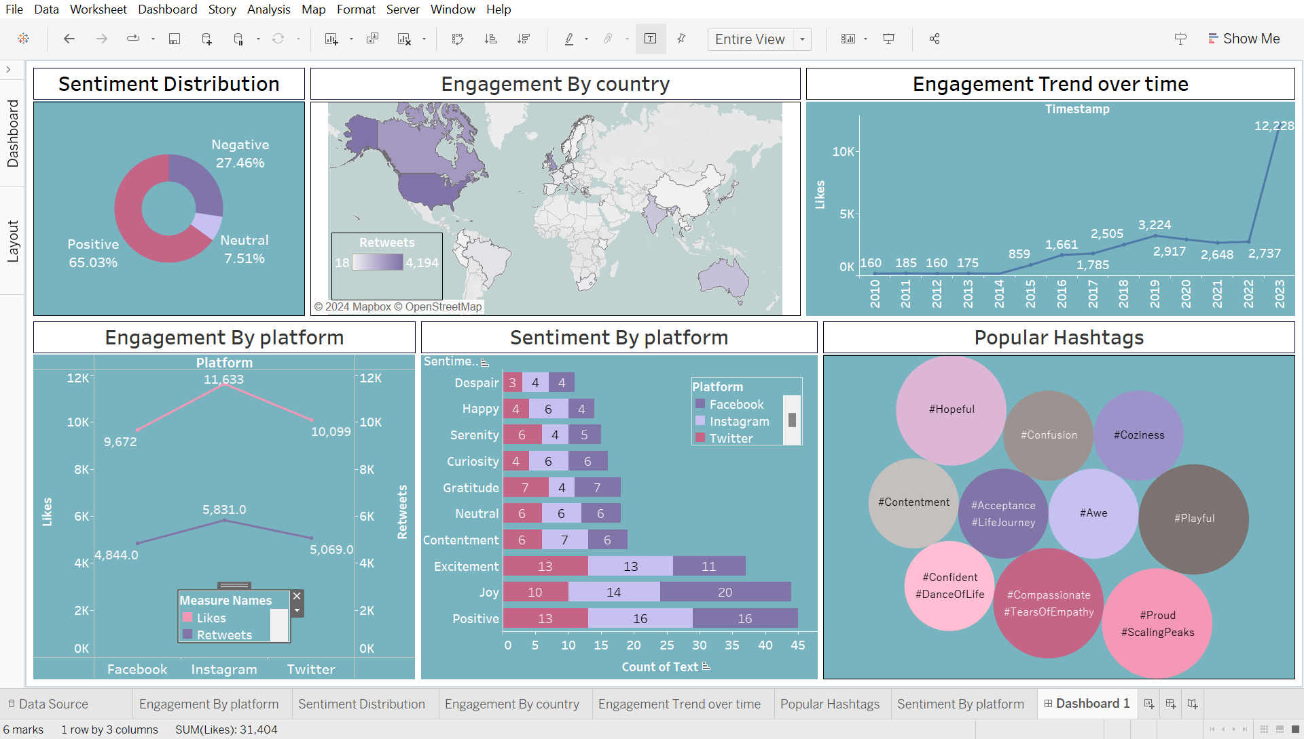
These visualizations were designed to allow easy identification of key trends and patterns, making it easier to draw actionable conclusions for optimizing social media strategies

- List of Analysis with results
- Sentiment Distribution
Analysis: Evaluate the overall sentiment distribution of social media posts.
Results:
- Positive Sentiment: Dominates with 65.03%, indicating a generally favorable tone across social media.
- Negative Sentiment: Makes up 27.46%, suggesting some dissatisfaction or negative opinions, but is significantly less than positive sentiment.
- Neutral Sentiment: Accounts for 7.51%, showing that a small portion of posts remain neutral or indifferent.
ii)Engagement by Country
Analysis: Compare social media engagement (likes, retweets) across different countries.
Results:
- The United States and Canada show the highest engagement levels (4,194 retweets), indicating strong interaction in these regions.
- Australia and Europe also have notable engagement, though less than North America, which could suggest either a smaller user base or lower interaction rates in these areas.
iii)Engagement Trend Over Time
Analysis: Track the trend of social media engagement over time to observe growth or decline.
Results:
- There’s a clear upward trend, with likes increasing significantly from 2010 (160 likes) to 2023 (12,228 likes).
- This growth may indicate increased social media use, effective engagement strategies, or a growing audience over the years.

iv)Engagement by Platform:
Analysis: Assess engagement levels (likes, retweets) on different platforms.
Results:
- Facebook has the highest engagement in terms of likes (11,633 likes), followed by Instagram (10,099 likes), indicating Facebook's dominance for content engagement.
- Twitter has the highest number of retweets (5,069), which might suggest it’s more popular for content sharing and discussions.

v)Sentiment by Platform :
Analysis: Examine the distribution of different sentiments (e.g., excitement, joy, contentment) across platforms.
Results:
- Facebook has the highest counts for joy (20 mentions) and positivity (16 mentions), suggesting it’s perceived as a positive platform.
- Twitter has a higher count for curiosity and excitement but also has a notable amount of despair mentions, showing a mix of engagement on this platform.
- Instagram has balanced sentiment, with higher mentions of gratitude and excitement.
vi)Popular Hashtags:
Analysis: Identify trending hashtags to understand the most common themes and topics on social media.
Results:
- Popular hashtags include #Hopeful, #Contentment, #Acceptance, and #Proud, which may indicate themes of positivity and personal growth are prevalent in user posts.
- Hashtags like #Confusion and #Compassionate also appear frequently, suggesting some discussions around empathy or support topics.

vii)Temporal Patterns in Engagement:
Analysis:Evaluate engagement based on time to see if certain years or periods show increased interaction.
Results:
- There is a marked increase in engagement starting from 2019 through 2023, suggesting a recent surge in social media activity.
- This might be attributed to events like the global pandemic (which increased social media use) or other significant global events during this period.
viii)Insights and Strategic Recommendations:
Based on analysis:
- Content Strategy: Brands and influencers should focus on positive and motivational content since positivity is the dominant sentiment.
- Platform Selection: For higher engagement, Facebook may be preferred for content that seeks likes, while Twitter could be leveraged for posts meant to be shared or retweeted.
- Geographical Targeting: Campaigns aimed at North American audiences could yield higher engagement, while exploring growth in regions like Europe and Australia may also be beneficial.
- Hashtag Usage: Use trending hashtags like #Hopeful, #Proud, and #Compassionate to align with popular themes and increase visibility.

- Future scope
The future scope of this social media analysis project includes expanding data sources by incorporating additional platforms like TikTok and introducing new engagement metrics, such as comments and shares, to capture a broader perspective on user interaction. Enhanced sentiment analysis could provide deeper insights by analyzing emotions based on demographics, as well as detecting nuanced expressions like sarcasm. Advanced engagement analysis can identify top influencers, uncover user behavior patterns, and highlight preferred content types, offering a more comprehensive view of audience interaction. Hashtag analysis could be extended to study co-occurring hashtags, track how hashtags correlate with sentiment, and even predict future trending topics.
Geographical and temporal trends could be explored further by drilling down into region-specific sentiment analysis and analyzing seasonal engagement patterns. Predictive and prescriptive analytics, like forecasting engagement trends and recommending optimal posting strategies, could help businesses strategize more effectively. Segmentation of users based on engagement behavior and sentiment could enable targeted marketing, while linking engagement metrics to business outcomes, such as sales or customer support metrics, would allow for a clearer measurement of social media’s impact on business performance.
Enhanced visualizations, including interactive dashboards and customizable reports, would improve the accessibility of insights. Continuous model improvement is essential for accuracy, with regular updates to adapt to new social media trends, user language changes, and emerging engagement metrics. Together, these advancements would create a more comprehensive, actionable, and adaptable social media analysis framework that evolves alongside digital marketing needs and platform changes.

9.References

- Class Lectures
- tableau Software. (2024). Learn Tableau for Free with Tableau Public. Retrieved from https://public.tableau.com/s/
- https://www.youtube.com/watch?v=BTArwS4ljC4&list=PL7RSbI9s6KhgovdILZ-lIpW-LTkduE-ll

